BISSNET TPS Project
Full Lesson Plan
Teacher: MaryAnn Roll
Course: Living Environment
Grade Level: 9-10th grade
Date: August 6, 2014

Lesson Title: Solving the Mystery of the Dying Honeybee

I. Lesson Objectives: Students will be able to describe the impact on the food web when one species decreases.

II. Lesson Context: Ecology Unit. Key Words: Food Webs, Food Chains, Heterotrophs, Autotrophs

III. Standards:

IV. Materials: Projector, article,

V. Anticipatory Set/ The Hook:
- Show students in small groups the picture of the full supermarket and have them develop questions
- Have students choose the three most important questions that are open-ended
- Show students the second picture of the supermarket with much less produce
- Allow them to narrow the questions using the new picture
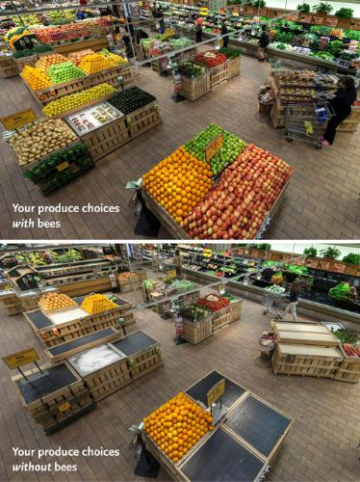

VI. Procedures:
- Hook
- Read article “If Bees go Extinct” using active reading strategies such as coding and bookmarking
- Students create an infographic comparing the supermarket and food web with bees and without bees. (http://piktochart.com/)
- Gallery walk of infographic

VII. Conclusion: The lesson ends with gallery walk of the students’ infographics

VIII: Assessment: Check for understanding throughout lesson, reading comprehension questions, discussion, and infographic.

IX. Differentiation:
- Have readings at various levels
- Allow students to choose their reading strategy
- Grouping of students
- Lesson includes multiple learning styles

