BISSNET TPS Project

Teacher: Lisa J. Baco
Course: Studio in Art
Grade Level 9-12
Date: 8/6/2014
Dates of Lesson: October 2014 (3- 40 minute lessons)

Lesson Title: Design is Everywhere/”The Shape of Things to Come”

I. Lesson Objectives: Through the process of inquiry students will become familiar with the impact of everyday objects on our perception of “design”. Second part of lesson will have students rendering an everyday object in a new form.

II. Lesson Context: Design is all around us. Someone designs everything you use. So many things have changed in your lifetime as far as their design. Thinking about what function the object has, sometimes influences its shape. Some shapes are naturally occurring in nature, some are man-made.

III. Standards:
Standard 1: Creating, Performing, and Participating in the Arts
Standard 2: Knowing and Using Arts Materials and Resources
Standard 4: Understanding The Cultural Dimensions and Contributions of the Arts

IV. Materials:
i pads, apple TV, magazines, scissors, glue sticks, sketchbooks, color pencils

V. Anticipatory Set/ The Hook:
Photo of everyday objects: i phone, orange, dollar bill , sneaker. Projected on screen to generate questions about these objects. 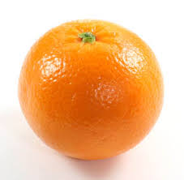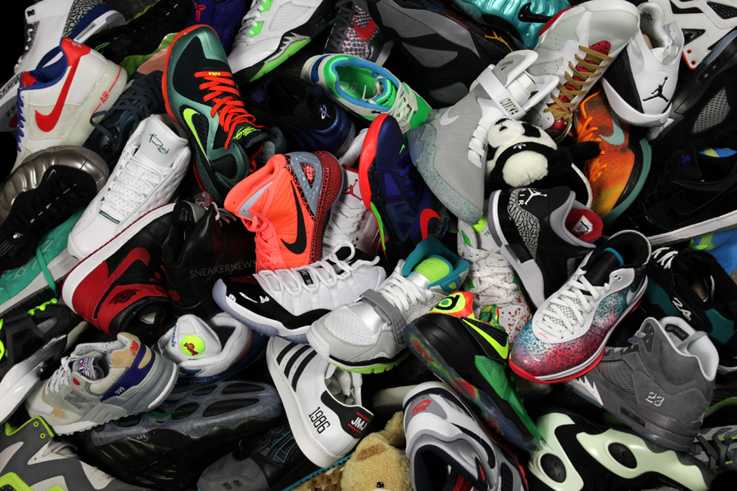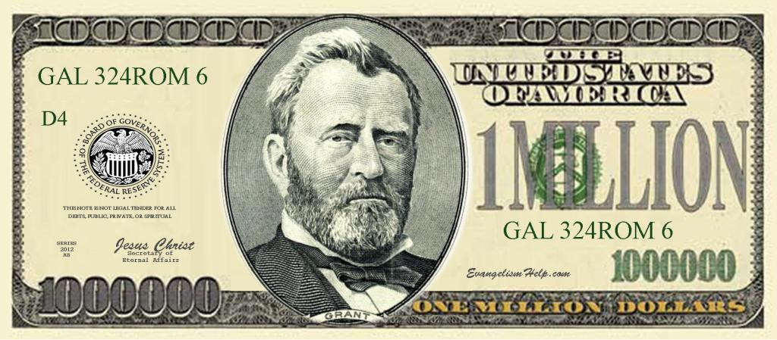

VI. Procedures:
Projected image(s). Using QTF, work in groups of four, share best question using ipad.

On i pad and/or magazines, students will find at least 10 images that have the same inherent shape. (Circle, square, rectangle etc. ) Choose one of the objects and force –fit chosen object into a new shape, keeping as many of the original characteristics as possible. Render the new object with colored pencils.

VII. Conclusion:
Using QTF students will have enhanced understanding of observation of objects.
Lesson ends with student drawing of a new version of an existing object.
Lesson ties in with future lessons of how all aspects of design are linked. Previous lesson had to do with line and color. This lesson covers shape and texture. These are four of five design principles we cover early in the curriculum.
Color, shape and texture Explain how the lesson ends, does it tie into prior/ next lesson.

VIII: Assessment: Original discussion of projected photos will have students using vocabulary that pertains to art. Observation will include noticing color, shape and detail. Since so much of creating art pertains to observation this is a very important part of the lesson. The use of QTF should be helpful in building observation and speaking skills. Students will use art terms when explaining their new renderings.

IX. Differentiation:
Modifications include using tactile objects in stead of or in addition to projected images for sight impaired individuals. The use of ipad and projected photos does make it easier for mobility challenged students.

X. Reflection: The changes could be new images, or actual objects. Actually when thinking about being sight impaired, I really like the idea of putting an object in a box or bag and having the students explore it with no sight first.

XI. Librarian Plan of Support: If you are paired with a librarian, please include a short description of how you will cooperate throughout the project.

