BISSNET TPS Project
Full Lesson Plan
Teacher: Alyssa Schwabe
Course: Lower School Science
Grade Level: 4
Date: August 6, 2014

We All Take Part:

I. Lesson Objectives: Through the process of inquiry, students will understand the impact of communities and individuals on Lake Erie water health. Students will have had experience identifying local and global fresh water resources, conservation and human impact on a local and global scale. Students will have taken a field trip of the industrial history along the Buffalo River aboard the commercial tour boat.

II. Lesson Context: Students will have an understanding of the limited amount of fresh water on our planet, where our local water comes from, and the impact communities and individuals have on fresh water.

III. Materials:
- Smart Board with image http://www.bing.com/images/search?q=Lake+Erie+Algae+Photos&id=7C57EFEFB9FC0B6E0021934A3CAB9E28BDE1F640&FORM=IQFRBA&adlt=strict#view=detail&id=7C57EFEFB9FC0B6E0021934A3CAB9E28BDE1F640&selectedIndex=0
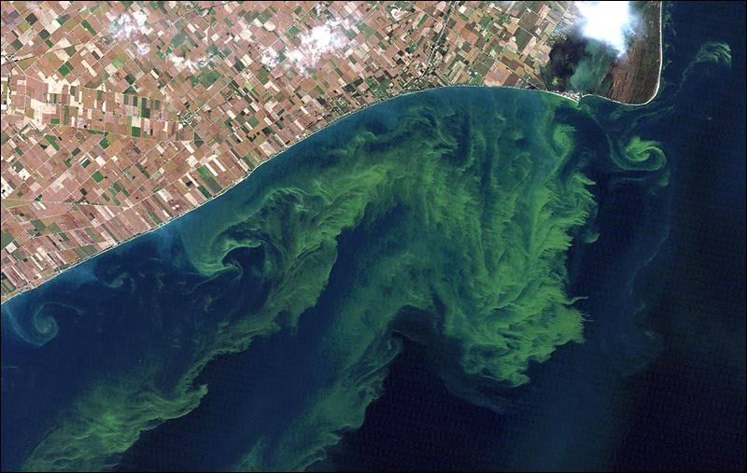

- iPad with writing capabilities for each group
- one piece of paper for each student (8 1/2”x 11”)
- variety size and color of pom-poms
- markers, colored pencils
- 1 piece of blue construction paper/fabric
- Digital cameras students to document trip
IV. Anticipatory Set/ The Hook: Students will view above image on Smartboard. In small groups will ask as many questions as they can, recording questions directly as stated in a given amount of time (5 minutes). Group will decide three best questions to further explore. Student groups will share questions.

V. Procedures:
- Tell students they have been given a plot of waterfront property and $1 million to spend to develop it. They should draw a picture of their plan (vertical format) with the water’s edge at the bottom.
- Teacher should also participate drawing a plot of land with many impacts to the local water shed (parking lot, helicopter pad, animals, farm, amusement part, power boat docks, garden…).
- Students should connect two water’s edges together on the floor; continue with additional pairs to form a long river with blue construction paper at the end.
- Students will recognize the body of water is a river, emptying into a lake… Lake Erie.
- Teacher should share how they developed their land at beginning of river, ask if their land has any impact on the lake. Place a few pom-poms on drawing to represent contaminants contributing to the water. Have adjacent and students share how they developed their land, passing out pom-poms representing negative impacts, and moving them ALL downstream towards lake.
- Recognize that even the organic farmers and those using more sustainable methods also contribute to the health of lake and are impacted by actions of others up stream.

VI. Conclusion: All pom-poms should end up in the lake.

VII: Assessment: What are student observations? Who is responsible for the contaminants in the lake? What would they change on their plot of land to produce less on an impact on river and the lake. Is this really happening? Refer to Smartboard image. Discuss their questions further; identify this image as lake Erie. Discuss the algae bloom and causes for it, who is responsible for it? What impacts do algae blooms have on communities along shore lines and those that get fresh water from the lake. Discuss what is being done as a community to preserve lake water, what do students do individually already? What can students do better? Share photos from trip, sort into images that directly impact in negative ways, what images are proof that positive actions have been taken; river and lake health is improving (water fowl, people using the water for recreation, commerce).

IX. Differentiation: Photo documentation of field trip, video made available for students unavailable to attend.

X. Reflection:

XI. Librarian Plan of Support: If you are paired with a librarian, please include a short description of how you will cooperate throughout the project.

