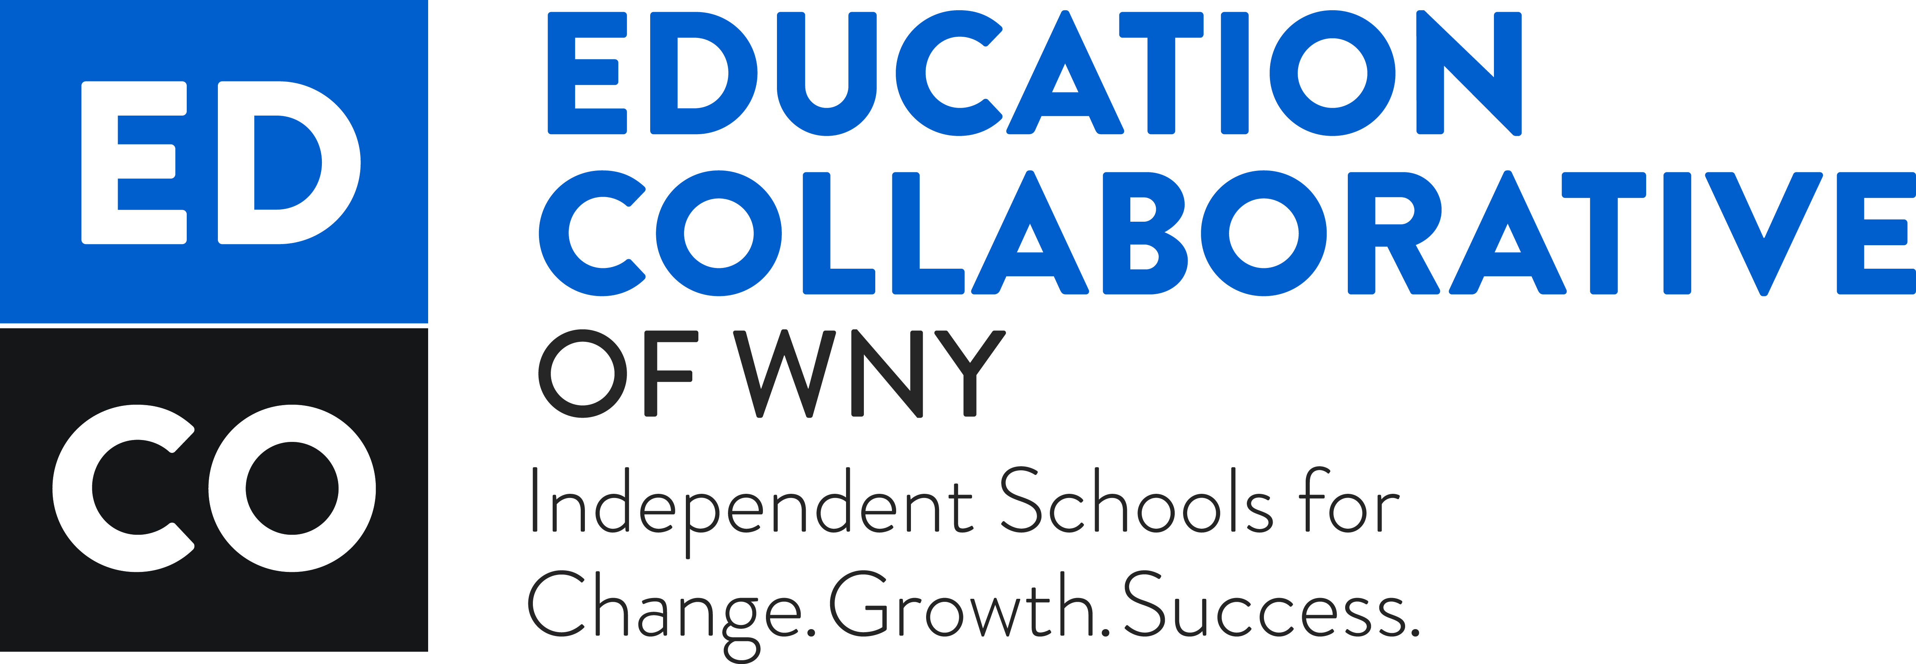

Librarians Meeting
Buffalo Academy of the Sacred Heart (Library)
March 12, 2015
9:00AM – 10:00AM

Agenda

- Introduction

- Brief Overview of the NEW EdCo Collaborative Groups Format

- Group Chair and Co- Chair Elections

- Creation of Group Purpose and Goals

- Open discussion

- Announcements

- Adjournment

